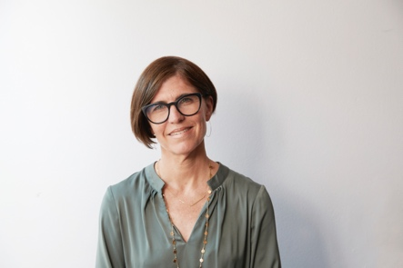

Dr Carla Croft, Consultant Clinical Psychologist
Head of Staff Psychological Wellbeing and Service Lead

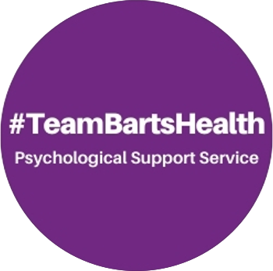

Carla started her career in 1992 as a research psychologist working in the area of developmental psychology as a doctoral student at University College London, focused on studying the impact on development of attachment relationships. After her PhD she went on to work as a post-doctoral researcher on a groundbreaking longitudinal study of development after privation and loss with Professor Sir Michael Rutter and team at the Institute of Psychiatry.

After gaining her clinical qualification at Royal Holloway, University of London she has worked for 23 years as a Clinical Health Psychologist in acute settings across the NHS, working and leading in several areas including women’s health (including maternity), cancer and palliative care, chronic fatigue and surgery.

Carla was redeployed, in March 2020 when the pandemic hit, to help set up and lead specialist psychology services for NHS colleagues. With the support of Barts Charity in 2021 she and a newly establish established team of psychologists set up a compassionate psychological support offer for all staff at Barts Health, that serves as a model to other trusts. She and the team now lead a network of psychological support services from 42 acute trusts across the UK that meets several times per year to collaborate. A major focus of her current work is understanding the impact of trauma specifically for those working in healthcare.

Through the Barts service Carla is proud to help ensure the working landscape is safer and more inclusive for all. She is dedicated to listening and innovation that will ensure what the PSS team offers has the potential to meet the psychological needs of every person at Barts.

