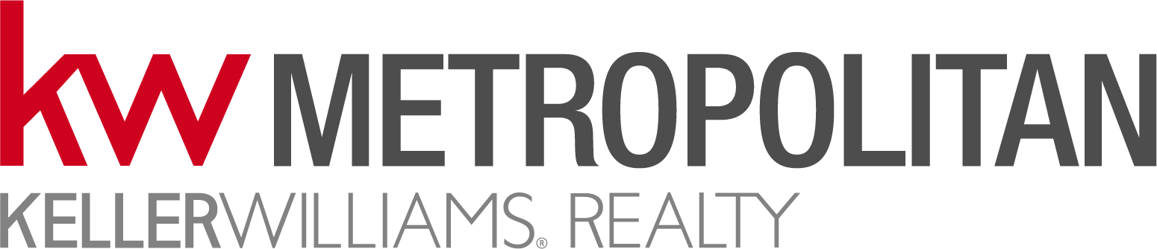
OPEN HOUSE - Visitor Sign In Sheet - New Hampshire
Property Address: Showing Date: Agent:
All Brokers/Salespersons represent the Seller in the marketing, negotiating and sale of property, unless otherwise disclosed.
The Broker/Salesperson has an ethical and legal obligation to conduct business honestly and fairly with the buyer in all transactions.
Ask about Buyer Representation.
Please sign in below. If you would like us to keep you informed about this property or other properties offered for sale, complete the other information.
*By providing your telephone number, you are giving us your consent to contact you at that number. Thank you for visiting our Open House.
Name | Address or E-Mail Address | Phone | How did you hear about this Open House? | Are you under contract with another agent?  (YES or NO)

The Broker/Salesperson hosting this open house is an agent of the seller and represents the seller in the marketing, negotiation and sale of this property. However, a seller’s agent has an ethical and legal obligation to treat all prospective purchasers honestly and fairly in all transactions and to disclose known material defects in a property.
A Broker/Salesperson does not represent a prospective purchaser unless the prospective purchaser arranges for such representation and signs appropriate documentation.

Thank you for visiting our Open House

