
As a member of the Keller Williams Luxury Community, we will be featuring your property on the following websites:


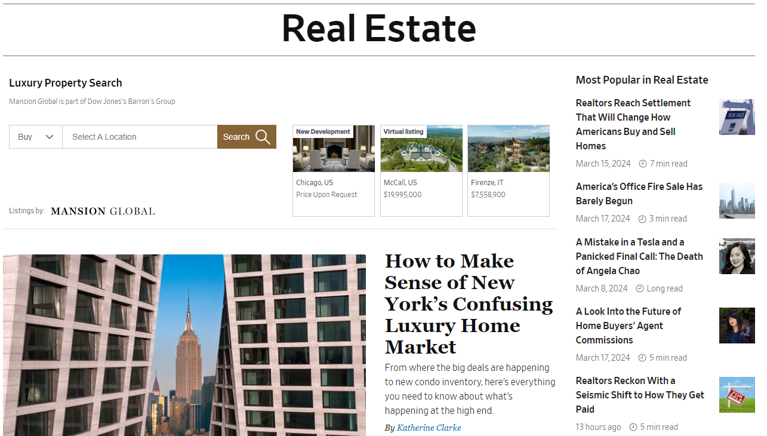

- WALL STREET JOURNAL REAL ESTATE
The latest news on real estate, including luxury homes, interior design, renovation, as well as insights and analysis on buying, selling or renting your home.
https://www.wsj.com/news/realestate
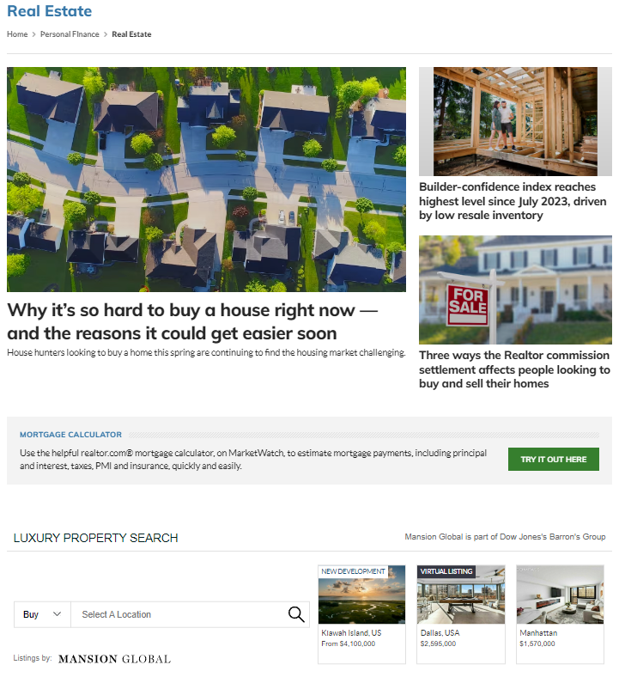
- MARKETWATCH REAL ESTATE
MarketWatch's guide to home buying, home selling, mortgages, home building, real estate investing, remodeling, hot home trends.
https://www.marketwatch.com/personal-finance/real-estate
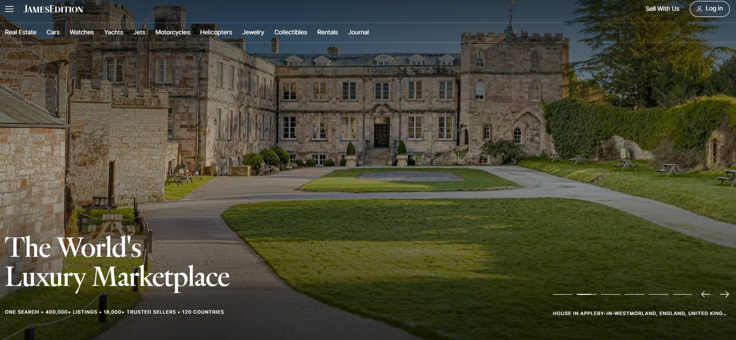
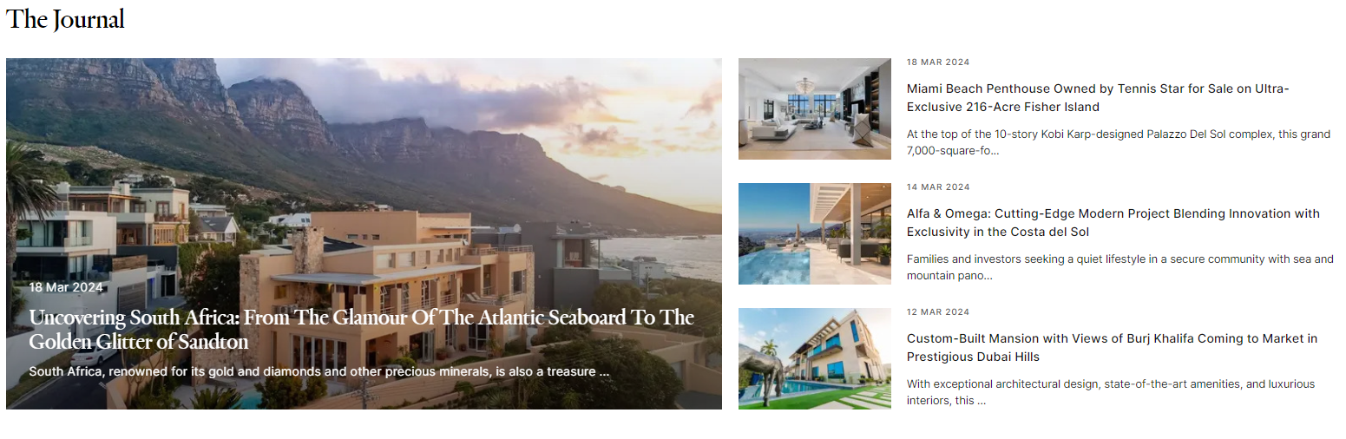3. JAMES EDITION
James Edition - The World's Luxury Marketplace. Explore 200000+ luxury listings: homes, cars, yachts & private jets for sale in 120 countries. View our active journal containing insights and trends of the ever-changing worldwide luxury landscape.
https://www.jamesedition.com/
Additional sites for Properties listed at $1 million and Up:
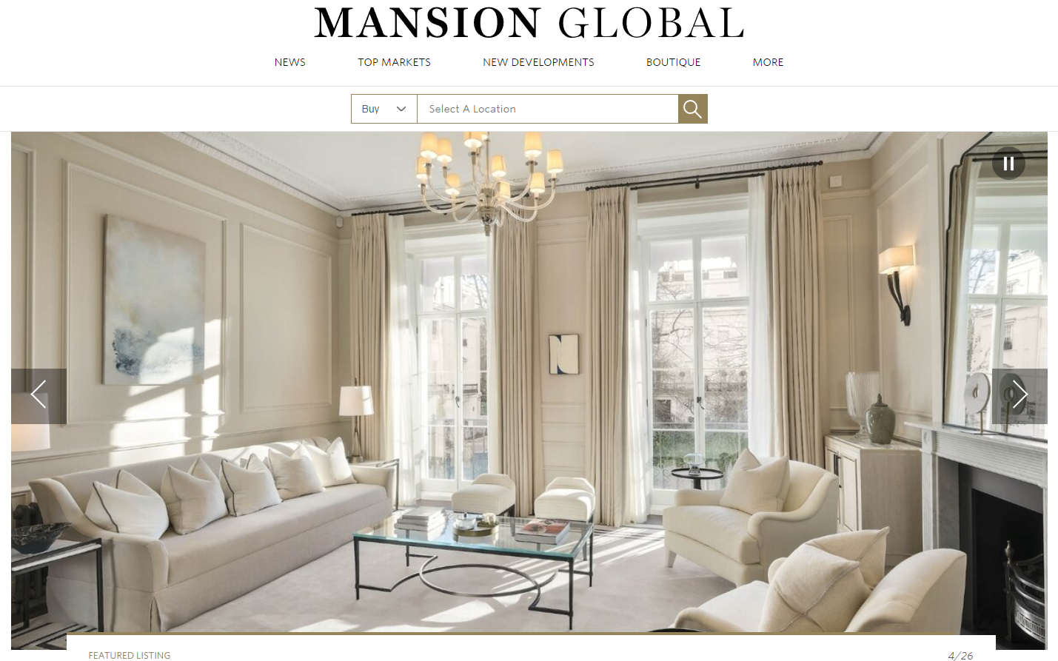
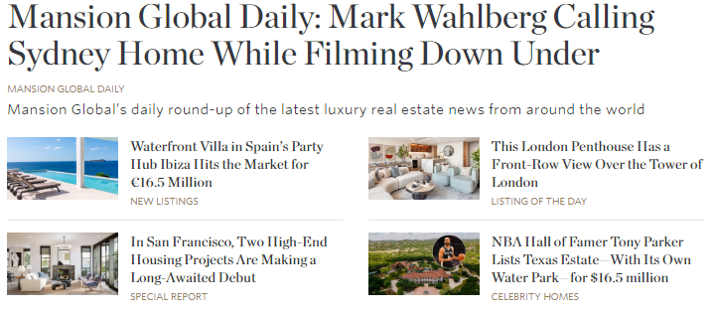
- MANSION GLOBAL
Mansion Global is the premier digital destination connecting the world's most affluent real estate buyers with prestigious properties around the globe through relevant, timely listings and compelling content. Our multilingual platform is localized to address the interests of international property seekers.
https://www.mansionglobal.com/

5. BARRON’S
Barron's is a leading source of financial news, providing in-depth analysis and commentary on stocks, investments and how markets are moving across the world.
https://www.barrons.com/


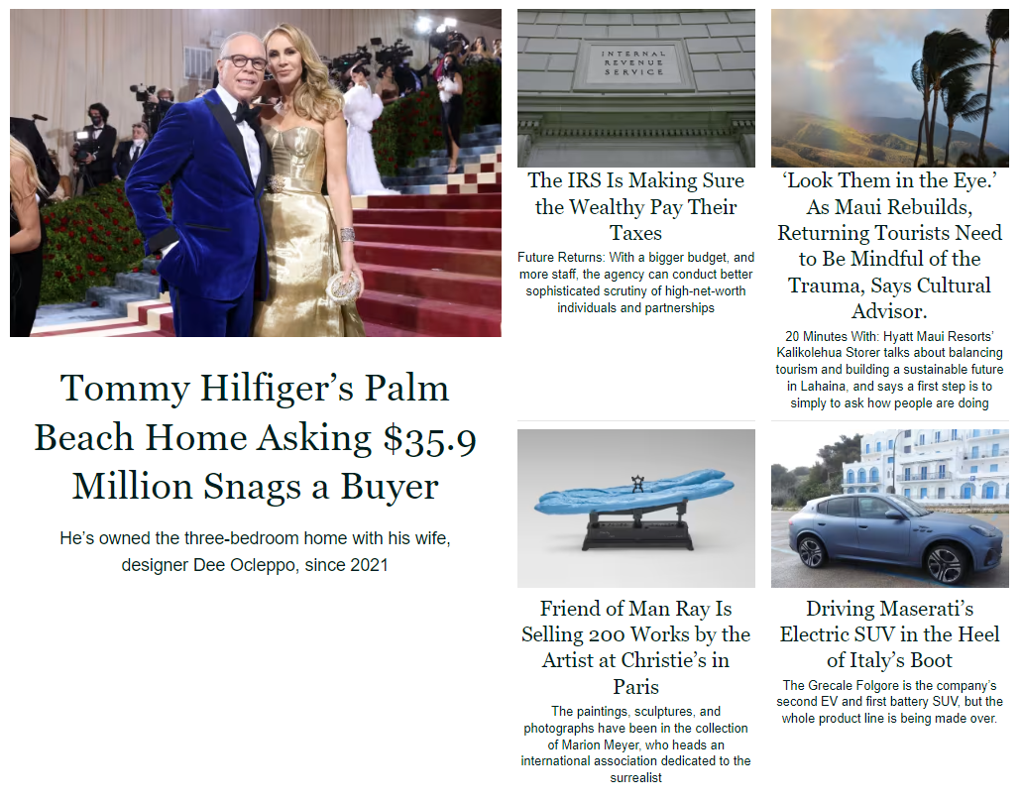6. PENTA
Experience. For those overcome by wanderlust and the inspiration to try something new, Penta profiles unique and adventurous luxury experiences. Advice for wealthy individuals on private banking, hedge funds, estate planning and trusts, philanthropy, luxury real estate, art collecting, autos, and much more.
https://www.barrons.com/penta

