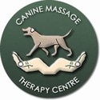
Pre-Interview Self-Assessment
Clinical Canine Massage Therapy Diploma
Awarding Body Gatehouse Awards
Welcome and thank you for application. Each year we take a limited number of students on the Clinical Canine Massage Therapy Diploma so please fill in this form as thoroughly as you can. Short, single word answers are insufficient.
We always advise anyone interested in the Clinical Canine MassageTherapy to attend a workshop first. Although it’s not mandatory, it does enable you to get a taste of what’s involved, meet your tutor and meet other students who are on the course too.
You can also watch our DVD ‘Canine Massage in 3 Easy Steps’ for a basic introduction into Swedish Massage. Please note that on the course you will cover Myofascial Release; the Direct & Indirect Approach, Remedial Sports Massage, Deep Tissue Massage as well as the full complement of Swedish Techniques. The course is the only one of its kind to teach the trademarked Lenton Method™ which is backed by clinical trials with both Winchester University and University Centre Sparsholt.
If you are interested in the Diploma we highly recommend submitting this form promptly in order that we can keep you up to date with news regarding the course and enable us to invite you to complete the next phase of the interview process. We will contact you in Autumn 2025 with a small written piece of work or ‘qualifier’ to complete before we arrange your phone interview. This application is for Course start date of 2026, Practicals in 2027.
For ease, you may copy and paste this into a word document or save as a PDF and email it back to us at admin@k9-massage.co.uk In the subject bar please entitle the subject as ‘CLINCAL CANINE MASSAGE THERAPY DIPLOMA APPLICATION’ PLEASE DO NOT EMBED INTO YOUR EMAIL
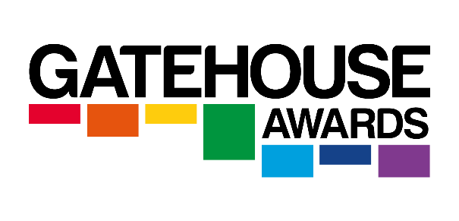
We will store the data that you provide for the period of the application only, for more information on our data & privacy policy please visit www.k9-massage.co.uk/terms-and-conditions/
We are proud that the awarding body is Gatehouse Awards, recognised by the regulatory bodies OFQUAL

Name: Date of application:
Age:
Town/City & County:
Phone Number:
Email:
Current Occupation:
Interested in: (delete as appropriate)
Weekdays (2/3 day blocks x 4) 2027; or
Weekends (2 day weekends x 5) 2027
Please note you will begin your written modules in Dec 2025/Jan 2026 Your practical dates will be in 2027
Do you have a Massage or Bodyworks Qualification/Training? Eg: ITEC/VTCT If yes please state what
Have you attended a Canine Massage Workshop with the Canine Massage Therapy Centre? If yes please state when. If you are planning on attending please state when.
Do you have any experience of Canine Massage? Eg: your dog has massage with a member of the Canine Massage Guild, attended a workshop, watched a DVD, read a book?
Would you like to be considered on our reserve list for a potential early start should a place become available?

Do you have any background/experience with dogs? This may be owning a dog, working e.g. grooming/vet nurse/ police dog handler, participating in a sport with your dog/training etc.. Have you lived with dogs yourself?

What first interested you in the Clinical Canine Massage Therapy Diploma?

What do you hope to achieve from taking the Clinical Canine Massage Therapy Diploma?

Please give brief details of any qualifications eg: O Levels or GCSES/A Levels/HND/NVQ/Degree/Professional Qualifications

Do you have any issues that may prevent you from working closely with dogs? Eg: back issues ie: slipped disc, uncontrolled epilepsy, arthritic hands/hips etc..

Self Assessment for fitness to practice: Please fill in each category
Do you consider yourself physically able enough to work with dogs? Canine Massage is a VERY physical job; a treatment is 1 hour long so you will find yourself either sitting on the floor or standing at a table for long periods of time. Are you able to realistically do this? We ask you to be as honest with yourself as possible as during practical weekends you will be expected to keep up with the rest of the group.

Do you like people? Can you easily spend time with new people and make them feel comfortable? Do you consider yourself a good communicator? In Canine Massage your human client will be sat with you while you treat your Canine Client, they do not leave the room as is the case with grooming. This means spending long periods of time with people, it is not a solitary job.

Do you like to study? The theory part of the course involves 11 written modules that take around 50 hours each. Although there is no pre requisite for this in terms of past qualifications the standard is very high with most modules coming in at around 5 000 words (more for Modules 1 & 2 which come in at around 10 000 words). This course involves a lot of Anatomy & Physiology so you should have a vested interest in learning more about the dogs’ body and understanding how it relates to massage.

Have you had experience of Canine Massage? Have you ever been on a Canine Massage workshop? Or had your dog treated by a Clinical Canine Massage Therapist? Or watched a DVD or read a book on canine massage? We recommend that you do at least 1 of the above to give you an idea of whether or not it is for you. You can attend a workshop with us (see our courses page) or buy the DVD ‘Canine Massage in 3 Easy Steps’ which is for the owner at home from our web shop.

Are you a Self Starter? Running your own business takes time, effort and dedication. Have you got what it takes?

How did you hear about the course?

Thank You for completing the Self Assessment. Now email it back as an attachment in WORD OR PDF to: admin@k9-massage.co.uk with ‘CLINCAL CANINE MASSAGE THERAPY DIPLOMA APPLICATION’ as the subject

Clinical Canine Massage Therapy Diploma
“Our Passion Is Your Success”

