Suya Lab
Loveth Rasheed Chiamaka

Restaurant Concept

Restaurant & URL
Suya Lab
www.suyalab.ng

Food & drink

Suya Lab is a delivery-only restaurant specializing in customizable suya platters. Customers can build their own suya experience by choosing from:
- Protein: Beef, Chicken, Ram, Plant-based
- Spice Intensity: Mild, Medium, Extra Hot
- Portion Size: Small, Regular, Large
- Extras: Onions, Tomatoes, Pepper Sauce, Fried Yam
- Sides: Jollof Rice, Fried Plantain, Salad
The menu is designed to be simple but highly customizable, allowing customers to tailor their suya order exactly to their taste.

Location
- Country: Nigeria
- City: Lagos
- Neighbourhood: Victoria Island (central, busy residential and business area)
- Delivery Radius: Victoria Island + Lekki Phase 1

Main target audience
- Young professionals (ages 18–35)
- Office workers and residents of Victoria Island & Lekki
- People ordering lunch, dinner, and night-time snacks
Cost

₦4,000 – ₦9,000 per order
(The range varies by portion size and added extras.)

Elevator pitch

Suya Lab brings the authentic taste of Nigerian suya to your doorstep with a modern twist, fully customizable to suit your spice preferences and portion size. Whether you’re craving a quick lunch, dinner with friends, or a late-night suya session in Victoria Island and Lekki, we deliver fast, fresh, and fiery flavours straight to you.

Strategy

Target Audience
Roles:
- Lunchtime office crowd
- Dinner orders for families & friends
- Night-time hungry group orders

Demographics

- Gender – Male/Femala
- Education - Students and young professionals
- Occupations - Tech-savvy and convenience-oriented
- Age - 18–35
- Location – Lagos, Nigeria

Psychographics (personality, values, attitudes, interests, lifestyles)

- Personality & Attitudes: Loves bold flavours
- Values: Enjoys convenience delivery
- Lifestyles: Values customization and choices

Strategy

User Needs
The website needs to enable the user to:

- Find out if the restaurant delivers to their area
- Order food online
- See the full menu with customization options
- Build their own suya platter step by step
- Place orders easily with delivery details
- View total prices as they customize
- Check delivery times and availability

Client Needs
The website needs to enable the client to:

- To sell food online that will be delivered
- Provide a system for order customization
- Capture online orders efficiently
- Communicate brand identity & spice quality
- Highlight menu customization clearly
- Encourage repeat orders and upsells (add fries, drinks)

Outline of Scope

Content Requirements
Content (text, images, video) that the user will need.
“The user will be looking for…”

- Home page with branding and call-to-action
- Menu page with customization builder
- About Us (brand story & quality commitment)
- Contact page + FAQ
- Delivery information & pricing
- Testimonials or reviews section

Functionality Requirements
Systems that will allow the user accomplish tasks.
“The user will be able to…”

- Select protein & spice level
- Choose extras & sides
- Add items to cart
- Enter delivery information and pay online
- Receive order confirmation notifications

Sitemap

INSERT SITEMAP IMAGE HERE
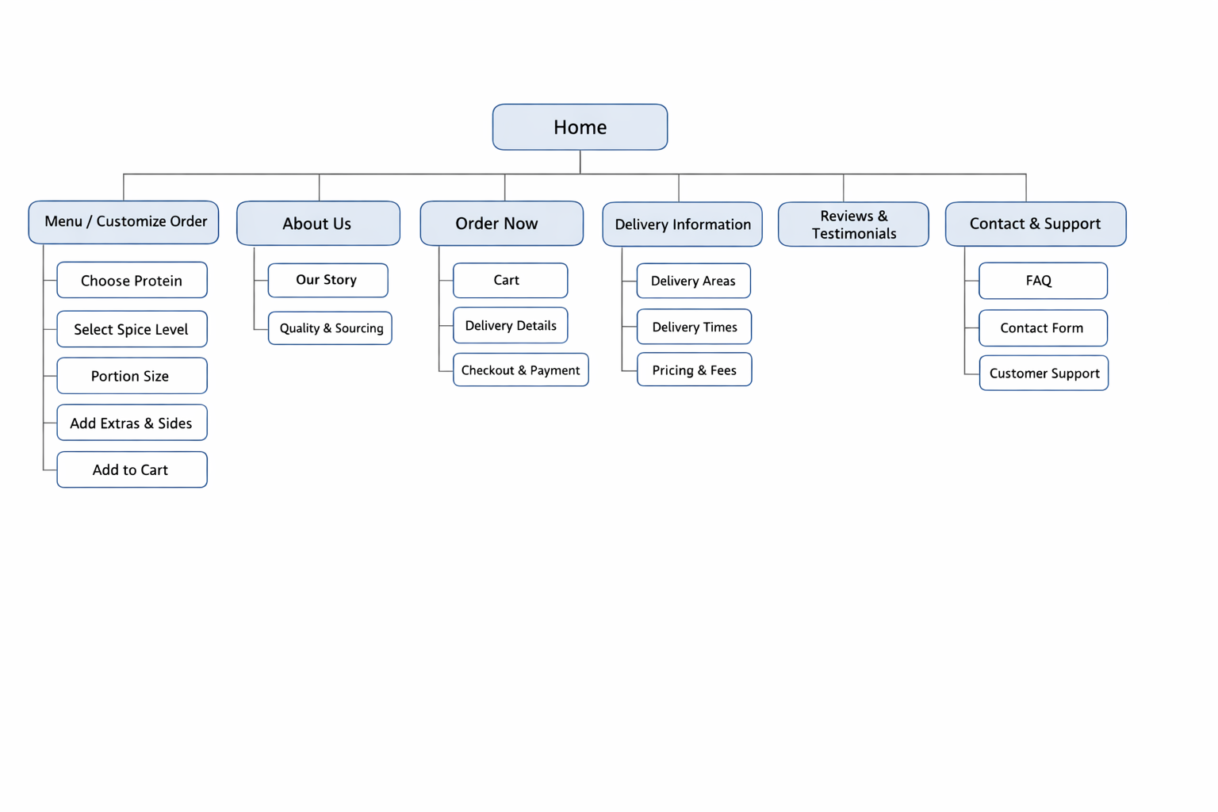

PERSONA

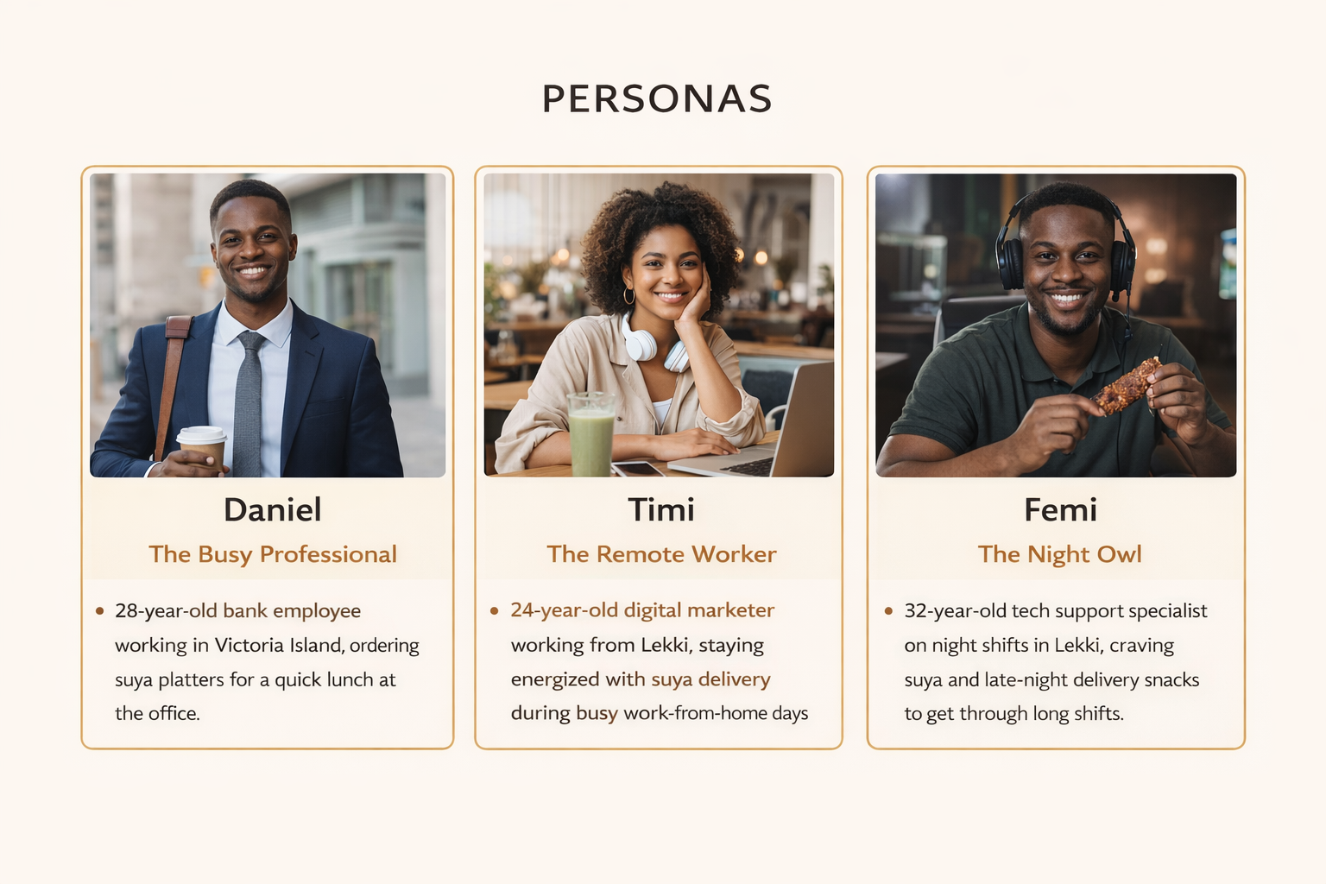

OUTLINE OF SCOPE

User Needs

1. How much does the suya cost?
Content Requirements:
- High-quality images of suya platters
- Clear text descriptions of each suya option (beef, chicken, ram, plant-based)
- Price labels for portion sizes (Small, Regular, Large)
- Short descriptions of extras and sides
Functionality Requirements:
- Buttons to select portion size and quantity
- “Add to Cart” call-to-action buttons
- Automatic price update based on selections

2. How can I customize my suya order?
Content Requirements:
- Text explaining customization steps
- Icons or images representing spice levels
- Labels for protein types and extras
Functionality Requirements:
- Step-by-step customization system
- Options to choose protein, spice level, and extras
- Ability to edit selections before checkout

3. How can I make payment for my food?
Content Requirements:
- Payment instruction text
- Icons/logos of supported payment methods
- Security reassurance text (safe & secure payments)
Functionality Requirements:
- Online payment system (card, transfer, USSD)
- QR code payment option
- Secure checkout process with confirmation message

4. Can I get my food delivered to my office or to someone else?
Content Requirements:
- Images showing food delivery in Lagos
- Text explaining delivery coverage areas
- Delivery pricing information
Functionality Requirements:
- Address input form for delivery location
- Delivery availability checker
- Integration with dispatch/delivery service
- Order tracking or delivery status updates

5. Can I leave a review or see what others think about the food?

Content Requirements:
- Customer reviews and testimonials
- Star rating visuals
- Short text prompts encouraging feedback
Functionality Requirements:
- Review submission form
- Star rating system (1–5 stars)
- Ability to view and sort reviews
- Option to contact support for enquiries

6. Who are you and why should I trust your brand?
Content Requirements:
- “About Suya Lab” text (brand story)
- Images of food preparation and ingredients
- Quality and sourcing information
Functionality Requirements:
- Navigation to About Us page
- Contact form for enquiries
- FAQ section for common questions

