Bonjour – Guten Tag – Buenos Días!
We hope you had an enjoyable half-term break and are feeling well and ready for the next half term. Your trainee should be teaching their full timetable now, as well as observing experienced colleagues once a week. As you know, even the most diligent of trainees can start to struggle with organisation as their workload increases and they may need additional support to submit their lesson plans 48 hours in advance as well as understanding the rationale for this. Should you need any ideas about how to approach this with your trainee, you might find this guidance helpful. As a reminder, we have a resource folder specifically for ML Mentors, containing all the documentation associated with the school placements.

Placement 1: Intensive Training and Practice [ITaP]
Next week, your trainee should “enact” another ITaP element, as outlined below. Please don’t hesitate to get in touch if you would like further clarification on this aspect of our curriculum. You can find the full ITAP schedule here.

Placement 1 - Week 7 | Core Area 4: Assessment
Placement 1 - Week 7 | 4A: Learn how to use assessment for learning strategies to check pupils’ prior knowledge and understanding
Placement 1 - Week 7 | Session | Enact
Placement 1 - Week 7 | 4A.1 Giving effective feedback  4A.2 Using effective questioning and error correction strategies  4A.3 Making effective use of data | Independently:  - Complete the Placement 1 Portfolio and use it to support completion of Masters Assignment 1: EDUC66620 Learning, Teaching and Assessment (LTA).  Observe how effective teachers:  - Give effective feedback.  - Use questioning to check pupil progress.  Together with your mentor:  - Discuss effective questioning techniques.  - Plan and teach a lesson in which questioning is used to check pupil progress.  - Reflect critically on teaching and learning; to identify how effective strategies can be applied to practice.

Support from WAPP coaches
Our professional WAPP coaches are able to provide additional one-to-one support for trainees, to help them engage effectively as they work towards becoming a confident and effective beginning teacher. Each session is tailored to meet the trainee’s needs and provides an opportunity to talk and work collaboratively to identify appropriate strategies for moving forward successfully. If you think your trainee would benefit from this scheme, please don’t hesitate to contact your trainee’s Personal Tutor.

Lesson observation and discussion
Many trainees are highly critical of themselves, and for some it may be the first time they have received negative comments about their performance, either in an academic or a work setting, so immediate verbal feedback, however brief, can help to alleviate any anxiety. As we are encouraging our trainees to become reflective practitioners, they should be invited to articulate their own feelings about the lesson before the observer contributes their own thoughts. The feedback might, therefore, begin with a question like “What were you happy with in the lesson?” and “Did you achieve your aims, and what evidence do you have?”, “How do you know that your pupils made progress?” and “What would you change if you taught the lesson again?”. Most trainee teachers are embarking on a very steep learning curve and might make what an experienced teacher would consider to be very basic mistakes. Whilst it will be important to consider what they can do to improve aspects of their teaching, please can we ask that your feedback is constructive, positive aspects of the lesson are highlighted, and strong aspects of your trainee’s teaching are highlighted; a trainee teacher’s confidence can suffer badly when they perceive feedback to be exclusively negative or when minor errors are a constant focus, and comments such as, ‘You should have…’ and ‘I would have….’ are less helpful. You may find these questions helpful to focus your lesson observation and your feedback to the trainee:

Did your trainee:
- Enable pupils to achieve the lesson objectives and learning outcomes?
- Enable pupils to learn something new?
- Enable pupils to use a range of skills i.e., reading, listening, speaking, writing?
- Demonstrate good subject knowledge e.g., use key terms correctly, address misconceptions?
- Model activities and give clear instructions using success criteria?
- Support pupils in committing content to long-term memory and not overloading working memory?
- Check pupils’ learning and progress regularly?
- Create a supportive and encouraging environment?
- Use rewards to encourage engagement and learning?
- Build on their pupils’ prior knowledge?
- Provide appropriate, interesting, and engaging activities which enabled all pupils to make progress?
- Enable all pupils to participate actively in the lesson?
- Prepare pupils for the next lesson?

Target setting
The target-setting areas on the Lesson Observation Report and in the Weekly Mentor meeting sheet support you and your trainee in co-constructing tightly focussed and achievable targets together. The process of target-setting is fundamental to the training process; to promote self-efficacy it is essential that your trainee has the opportunity to reflect on their progress towards their weekly targets. Please ensure your trainee has three targets at most at any given time and are given constructive advice and support in working towards their targets, which should be reviewed in the Weekly Mentor meeting.

School visits
We will be starting our school visits next week and thought it would be useful to share with you the guidance we have given to trainees, particularly for those of you who haven’t worked with us before.
School Visit Guidance for Modern Languages Trainees

At least 48 hours in advance of the visit

Part 1: Planning and Teaching
Plan a lesson that enables you to demonstrate how you are applying the ITAP aspect of your PGCE programme to your developing practice. Specifically, a lesson in which:
- Core Area 1: Teacher Expectations [Behaviour for Learning]
  - High expectations of behaviour and engagement are communicated.
  - Clear routines are reinforced at the start and end of the lesson.
  - The school Behaviour Policy is applied consistently.
- Core Area 3: Planning and Teaching [How Pupils Learn]
  - The Target Language is used as a pedagogical approach, to support teaching and learning.

Part 2: Professional Behaviours
- Create a Visiting Tutor folder within your P1 RoAD.
- Save a copy of your lesson plan and resources in your Visiting Tutor folder.
- Complete the Visiting Tutor survey

On the day of the visit

Part 1: Lesson observation and discussion
Your Mentor and Visiting Tutor will observe you teaching your planned lesson and complete a lesson observation report. There will be a three-way discussion (normally about 45 minutes), when you will be asked to reflect on what went well and what you might do differently if you were to teach the lesson again, with a particular focus on:
- Core Area 1: Teacher Expectations [Behaviour for Learning]
- Core Area 3: Planning and Teaching [How Pupils Learn]

Part 2: Trainee progress and impact
You will be asked to reflect on the strengths of your practice and current areas for development.

Part 3: Tutor time
Your Visiting Tutor will spend about 10 minutes with you and your Mentor separately, to identify any support where needed.

Please remember that our aim is to provide you with constructive feedback that complements that which you receive from your colleagues.

Mentor meeting themes
These are the themes for the next three weeks of Placement 1. You will see that they link to our curriculum and encourage your trainee to focus on key areas of their practice. You might find the seminal paper Assessment and Classroom Learning (Black and Wiliam, 2004) useful for your Week 8 Mentor Meeting when the discussion centres around assessment and effective approaches to questioning and feedback.

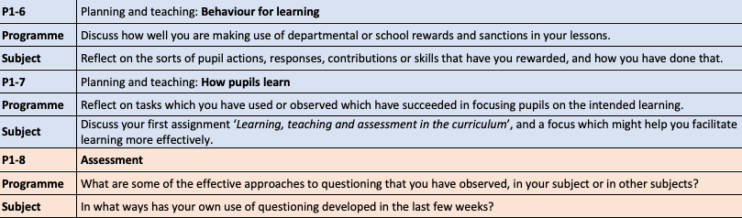

Masters’ Assignment 1: Learning, Teaching, and Assessment in the Curriculum (LTA)
A key tenet of becoming an effective teacher is being able to understand the links between classroom practice, the educational theories that underpin this practice, and the sociocultural context in which all this is rooted. Our three Masters’ level assignments have been designed to encourage your trainee to make this link in a reflective, considered manner. Assignment 1: Learning, Teaching, and Assessment in the Curriculum is associated with three Core Areas: (1) Subject and Curriculum Knowledge; (3) Planning and Teaching; (4) Assessment of our curriculum, and the Task Specification is given below so you can support your trainee in planning their series of lessons using their Placement 1 Portfolio (Assessment folder):

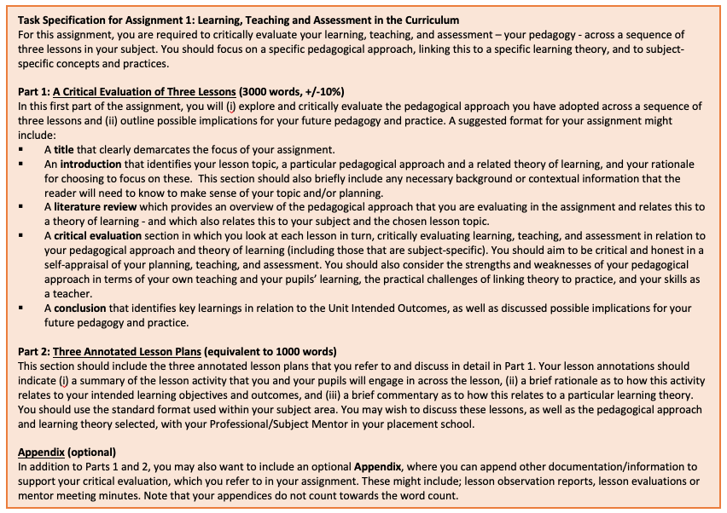

À Bientôt - Bis Bald - Hasta Luego!
We are very much looking forward to seeing you in school but in the meantime, please don’t hesitate to contact us should you have any queries about our visit procedures or documentation.

With kindest regards and thanks for your ongoing support of your trainee(s) and our partnership,


Your ML Team.

