Bonjour – Guten Tag – Buenos Días!
Many thanks, as always, for agreeing to host one of our trainees for Placement 2. They have proven themselves to be an excellent bunch and are very much looking forward to joining you on Monday, 12th January for Week 1 of their second placement. Your trainee has been allocated a Personal Tutor for their PGCE year; please don’t hesitate to get in touch with them if you have any queries or concerns.

Personal Tutor | Email
Joanne Taberner | joanne.taberner@manchester.ac.uk
Karen Roberts | karen.roberts-2@manchester.ac.uk
Andy Rose | andrew.rose@manchester.ac.uk

Placement 2: Mentor Training
We ask you to please watch the Modern Languages training video embedded in the email (approximately 20 minutes) in advance of attending our subject-specific online session on Thursday, 15th January from 16:30-17:30 via MS Teams. We would like this to be a collaborative effort that will not only strengthen our educational offering but also demonstrate our collective commitment to our own continued development. An attendance fee of £35 (less tax) can be claimed by all participants. Please sign up here.

Online Training MS Teams
Meeting ID: 329 839 260 033 90
Passcode: i8tM2SV9

Resources for ML Mentors
Please can we ask you to save a copy of and dip into our Modern Languages curriculum handbook that contains key information regarding our curriculum and outlines our expectations of trainees. You can find templates and exemplar materials in our ML Mentor Resources folder and on our Mentor training platform, Thinkific, which you can access via the hyperlink or this QR code below. There is now a new a new Lesson Observation Report for each placement, which directly references the practice statements in the relevant Progress Matrix. Please discard any previous versions and use only the new template for Placement 2 attached to the email.



Placement 2: Key Dates
Week 1: Induction Phase
Observe classes, undertake programme of induction activities

Week 2: Preliminary teaching
Observe classes and teach 2 to 4 hours, including some team teaching

Week 3: Preliminary teaching
Observe classes and teach 4 to 6 hours, depending on trainee progress

Week 4: Preliminary Teaching
Observe classes and teach 7 to 10 hours, depending on trainee progress

Week 5: Continued school experience
Teach full timetable (maximum 12 hours), depending on trainee progress

- Monday, 12th January Placement 2 starts - Week 1
- Friday, 30th January Trainees in University all day
- Monday, 23rd February Trainees in University all day
- Friday, 13th March Placement 2 finishes

Placement 2: Trainee Timetable
As you finalise your trainee’s timetable, you may find our trainee checklist below useful. Activities such as group work and team teaching can be included on the timetable, as long as your trainee is able to evidence planning. Your trainee needs to teach a maximum of 12 hours by the end of the placement and we ask you to please use this template regarding the gradual increase in teaching, to ensure consistency across our ML programme. In addition to the 10-12 hours*, your trainee should teach one lesson of PSCHE/RSE, be attached to a Tutor Group, and observe experienced teachers (1 to 2 lessons per week) as per the weekly focus in their RoAD. RoAD.
*not included in the 10-12 hours

Trainee timetable: Placement 2 | ☒
10-12 hours’ teaching by the end of the placement | ☐
Weekly Mentor Meeting* | ☐
One PSCHE or RSE lesson per week* | ☐
Tutor Group* | ☐
Observation of experienced colleagues* | ☐

Continued on next page…
Placement 2: Week 1 [Induction]
Your trainee has been told to arrive by 08:30 unless you give them a different start time. We ask that your trainee is able to undertake a programme of induction, observe some of the classes they will be working with, and familiarise themselves with departmental Schemes of Work. Extra observations may be required for Years 10 to 13, as your trainee may have had little or no involvement with these classes in Placement 1. We also ask you to set aside time to discuss your trainee’s Progress Report 1 and their action planning within their Progress Report 2. You may find the checklist below useful as you finalise your preparations:

Induction | ☒
Welcome and school/college introduction e.g., tour, staff roles, health and safety briefing | ☐
School/college policy and practice in key areas e.g., Behaviour, Child Safeguarding, Assessment | ☐
Department introduction e.g., Schemes of Work, textbooks, resources | ☐
Timetable of teaching | ☐
Class lists and seating plans to enable your trainees to learn pupils’ names | ☐
Discussions about the classes and pupils they will teach and Schemes of Work with relevant colleagues | ☐
Observation of the classes your trainee will be working with | ☐
Information on the attainment levels of pupils, including particular pupil groups e.g., SEND, EAL, PP | ☐
Access to reprographics, IT facilities and other services | ☐

Placement 2: Planning and teaching
We thought it might be useful to include reminder of the planning and teaching requirements for Placement 2:
- Your trainee must write a detailed lesson plan for each lesson or part of lesson taught (e.g., starter activity, plenary). A full lesson plan will likely extend across at least 3 pages including the cover page.
- Your trainee must script the Target Language they will be using as they teach each lesson.
- We ask that you allow your trainee to use and adapt existing departmental resources (e.g., PowerPoints, worksheets, games).
- Your trainee must plan from scratch and create a Scheme of Work and an Assessment Portfolio for one class, to support them with medium-term planning and monitoring pupil progress. Please can you help your trainee to identify an appropriate class; ideally one which they will be teaching soon after the start of the placement?
- Your trainee must submit the hyperlink to their lesson plans and PowerPoint to the class teacher 48 hours in advance (working days) to allow feedback to be given and acted upon e.g., Lesson = Monday, period 3; Submission = Thursday, period 3.

Intensive Training and Practice [ITaP]
As most of you will know, ITE providers are now required to have an ITaP element to their programme. The ITAP element is designed to give trainees feedback on foundational aspects of the curriculum where close attention to and control of content, critical analysis, application and feedback are required. Feedback from our External Examiner suggested we might like to make the school-based parts of our ITaP provision more explicit. To this end, we ask you to please look at the ITaP guidance attached to the email to see what your trainee is required to do during the placement, which will provide the subject-specific focus for your weekly mentor meeting. Please see below for an example. We would very much welcome any feedback on this aspect of our provision at the end of the placement.

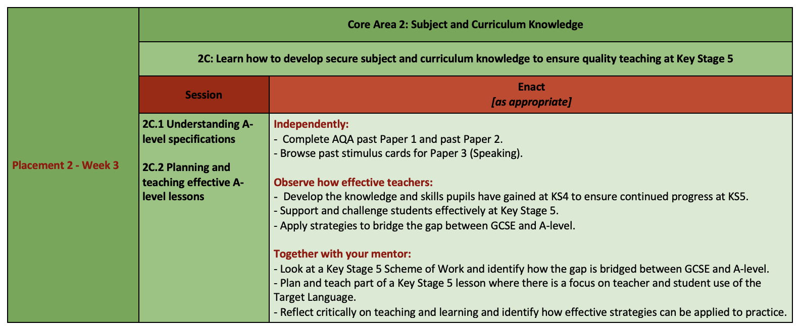
Placement 2: Record of Achievement and Development (RoAD)
Your trainee stores all their documentation and evidence in their RoAD on Google Drive, enabling all colleagues involved in their training to review and assess their work and progress. Your trainee is required to update their RoAD weekly, to maintain good organisation and be ready to submit their evidence by the deadline of Friday, 21st March. If you would like to see what your trainee needs to do each week, you can look at their Weekly Programme and their Weekly RoAD updates sheet, from which you can also locate key documents.

Continued on next page…
Placement 2: Modern Languages Curriculum
The table below outlines our ML curriculum for U2-P2. Through our university sessions, we aim to answer one key question for each of the five Core Areas as stated in the Implementation column. The Impact column provides a concise overview of how we expect our trainees to be working in school during Placement 2 to be on track against each Core Area, which you might find useful.

Secondary PGCE Modern Languages Curriculum: U2-P2
Deepening understanding and impact on learning, building curricula, and developing agency
UoM Curriculum Area | Modern Languages Curriculum  Intent | Modern Languages Curriculum  Implementation | Modern Languages Curriculum  Impact
Core Area 1:  Teacher Expectations | Understand that high expectations of pupils’ attitudes, values, behaviour and progress are central to positive achievement outcomes. | How do teachers’ expectations impact pupil achievement outcomes? | Communicate high expectations of achievement outcomes for all pupils.
Core Area 2:  Subject and curriculum knowledge | Understand that secure subject and curriculum knowledge support quality teaching and learning in Modern Languages. | How do we develop secure subject and curriculum knowledge to ensure quality teaching and learning at Key Stage 4 and Key Stage 5? | Demonstrate developing subject and curriculum knowledge from Key Stage 2 to Key Stage 5.
Core Area 3:  Planning and Teaching | Understand that adaptive teaching supports an inclusive and positive learning environment and enables all pupils to achieve regardless of prior attainment or background. | How do we adapt a range of pedagogical approaches to create an inclusive learning environment that enables all pupils to achieve regardless of prior attainment or background? | Plan and teach consistently good lessons at Key Stage 3 and plan and teach good lessons at Key Stage 4 with increasing consistency.
Core Area 4:  Assessment | Understand that effective marking and feedback strategies inform planning and teaching and promote pupil progress. | How do we use marking and feedback strategies to inform planning and teaching and promote pupil progress? | Use effective marking strategies to inform planning and teaching and promote pupil progress.
Core Area 5:  Professional Behaviours | Understand how to develop as a confident, committed and effective teacher of Modern Languages who works collaboratively with colleagues to manage workload and wellbeing effectively. | How do we collaborate with departmental colleagues and other professionals to manage workload and wellbeing effectively? | Collaborate with departmental colleagues and other professionals to manage workload and wellbeing effectively.

À Bientôt - Bis Bald - Hasta Luego!
You will receive our next Mentor Bulletin in February, but in the meantime please do let us know if you need anything. We also have a Subject Mentor Padlet where you can post non-urgent questions and read other FAQs.

With very best wishes for a peaceful and healthy 2026,

Your ML Team.


