Introduction to the “Pharyngocise Program”
Self-study short course in Head Neck Cancer prophylactic exercise intervention

Course presenter:
Giselle Carnaby, M.P.H, Ph.D., SLP, FASHA, HONORS

Course Description: This self-study course will prepare Speech-Language Pathologists (SLPs) to provide therapeutic, evidence-based prophylactic exercise treatment to adult patients who are undergoing medical treatments for Head and Neck cancer. This course includes required review handouts, videos of the lecture and case examples.

Course Objectives:

Upon completion of this certification course, participants will be able to:
- Describe current medical treatments for Head Neck cancer and the effect of these treatments on the Head Neck musculature and swallowing system.
- Explain the various swallowing profiles for patients with Head and Neck cancer.
- Explain the impact and research evidence underlying prophylactic swallowing exercises in the Head Neck cancer population.
- Describe issues related to non-adherence in swallowing exercise in this patient population and methods to buffer this phenomenon.
- Select and describe the specific components of the Pharyngocise program for patients with Head and Neck Cancer
- Implement Pharyngocise techniques and strategies to increase movement of patients’ swallowing structures, support psycho-social independence, and improve recovery

Speaker Bio:
Giselle Carnaby is an experienced SLP clinician, and Professor of Internal Medicine and Professor in the Department of Communication Sciences and Disorders at the University of Central Florida. She specializes in research epidemiology and biostatistics. Her research focus lies in the rehabilitation of swallowing disorders following Head and Neck Cancer and Stroke. She has well over 100 publications in both national and international journals on these topics. She been funded as PI on both NIH, FLDOH and American Cancer Society grants. She is a lifetime Research Scholar for the American Cancer Society, Fellow of the American Speech Language & Hearing Association (ASHA), and holds ASHA Honors of the Association.

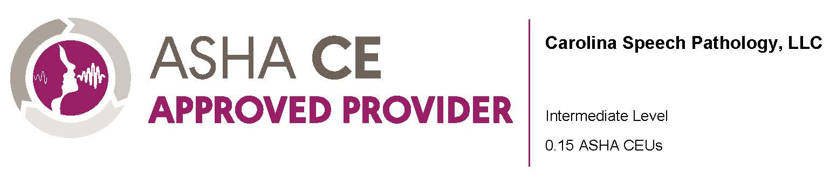

Course Agenda:

00:0 -1.09: Welcome, Introduction to instructor and Instructions.
01.10 -10.00: Chapter One – setting the scene –
- Basic demographics
- Common medical treatments
- New interventions
- Common swallowing problems
- Post chapter quiz 1 (3 multiple choice questions)

10.00 –25.00: Preventing dysphagia in HNC
- Current treatments for dysphagia
- Philosophy and components of prevention
- Effect and impact of prophylactic exercise in HNC
- Current prevention treatments and supporting research in HNC
- Post chapter quiz 2 (4 multiple choice questions)

25.00 -50.00: The Pharyngocise program
- Pharyngocise components
- Research evidence supporting the program
- Program impacts
- Timing of intervention using the program
- Step by step instructions
- Post chapter quiz 3 (4 multiple choice questions)

50.00 -75:00: Pharyngocise case studies
- Comparison of three similar cases
- Swallow imaging results
- Impact of Pharyngocise on physiologic and clinical metrics
- Impact of Pharyngocise on muscle measurements
- Role of the SLP in administering Pharyngocise
75:00 – 85.00: Final Thoughts
86.00 - 90:00: Clinical Take-aways
90.00: Adjourn

*Don’t forget to take the post-test!

Disclosures:
Course Disclosure: This course focuses on the Pharyngocise method of prophylactic treatment for Head and Neck Cancer.

Speaker Disclosure:
Giselle Carnaby has the following financial disclosure: She is an employee of the University of Central Florida; and partner in the Florida Dysphagia Institute (FDI), LLC.
Giselle has no non-financial disclosures.

Webinar Notice:
Successful participation in this course includes completion of all chapters and chapter quizzes, as well as completion of the post-test with a score of 80% or higher. A course completion certificate will be generated automatically following successful course completion. If you would like to have your participation reported to ASHA, it must be indicated on the registration form. Participation will be reported to ASHA on a monthly basis.

